17-442/17-642: Software Management Theory

Tuesdays and Thursdays, 5:00 – 6:20PM

A4, Spring 2025, 6 Units

Instructor Email Office Location & Hours

|  |  |  |
| --- | --- | --- |
| Prof. Eduardo Miranda | mirandae @ andrew.cmu.edu |  |

**Course Description.** This course will look at software development from an organizational behavior perspective. It its designed for students who want to understand the relationship between business context, software development processes, knowledge creation, culture and organizational structure with the purpose of becoming change agents or manage the software development function at the department, business unit level or above.

The course will also highlight the need to follow good work principles in order to avoid ethical failures as evidenced by recent affairs.

The course consists of instructor lectures, student presentations and the analysis of a case study. It involves weekly readings and short quizzes to keep up with the pace of the lectures.

**Prior Knowledge.** Exposure to software development activities, undergraduate course in Software Engineering

**Learning Objectives.** After completing this course, students will be able to:

* Explain the main theories of leadership, motivation and team dynamics
* Explain common coordination mechanisms, organizational knowledge creation and control
* Explain the fundamentals type of organization structures
* Understand the many variables to be contended with in a given organization design, the relationships between them and how to intervene in a congruent manner
* Apply systems thinking to the evaluation of future consequences arising from the decisions made today

**Learning Resources.** Reading material will be provided. Representative readings include:

|  |
| --- |
| Mintzberg, The Essence of Structure |
| Nonaka, Dynamic Theory Organizational Knowledge Creation |
| Allen, The Flow of Communication in Space |
| Ouchi, Conceptual Framework for the Design of Organizational Control Mechanisms |
| Larman, Feature Teams |
| Wenger, Communities of Practice |
| Hersleb, Architectures, Coordination, and Distance: Conway’s Law and Beyond |
| Andrew, Collaborative Software Development Based on Sociotechnical Networks |
| Stol, Inner sourcing tutorial |
| Larman, Systems Thinking |
| Braun, System Archetypes |

# **Course and Grading Policies**

Lectures in which the group is due to present or discuss an assignment, as indicated in the syllabus are mandatory. Being absent, without cause sanctioned by the instructor, will result in the forfeiture of the grade. The grading philosophy is explained on Figure 1.

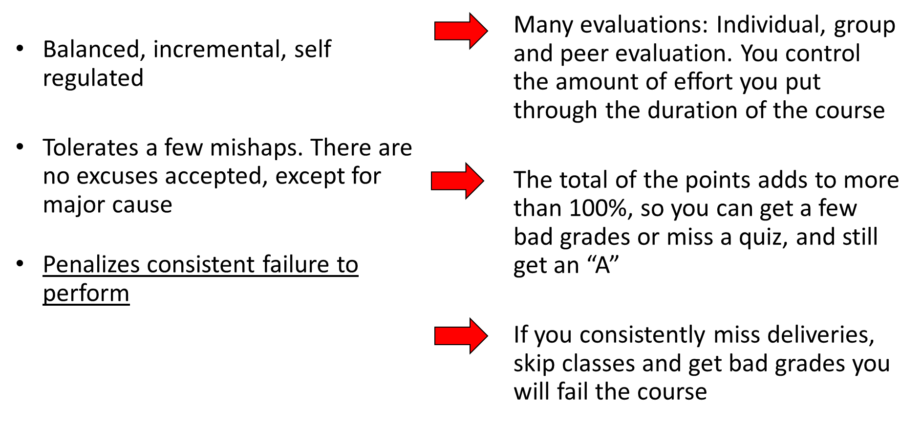

Figure Grading philosophy

Final grades in the course will be assigned according to the following scale:

* Maximum number of points = 114
* 110+ points, “A+”
* 100+ points, “A”
* 90+ points, “A-”
* 80+ points, “B+”
* 70+ points, “B”
* 65+ points, “B-”
* 55+, “C”
* “D”

Attendance, quizzes, and assignments

* 11 quizzes, 0 – 4 points each, 44 points maximum
* Assignment 1, Process analysis: 0 – 20 points
* Assignment 1, Teach your peers: 0 – 20 points
* Assignment 2, ING Agile Transformation: 0 – 20 points
* Peer evaluation: 0 - 10 points

CANVAS Quizzes

* These quizzes serve a triple purpose:
  + To track class attendance
  + To make sure the students look back at the material presented in class and the readings
  + To verify the understanding of the concepts and clarify when necessary
* For regular students, quizzes must be taken on the day the class was taught and within the next day by distance students. Each quiz, once started, must be completed in a 10 minutes window
* Individual, “Open book”
* Typically, 2 to 3 multiple choice questions referring to what was presented in the slides in the previous lecture and the indicated readings
* Two types of questions:
  + Questions testing knowledge of terminology, categories and classifications
  + Questions testing principles and generalizations. These questions can have more than one correct response, but there are some better than others
* Grading
  + 1 point for taking the quiz
  + Up to 3 points for correctly answering questions

Assignments

* Group assignments, one file per group consolidating all the material produced by the group
* Submissions must be:
  + In PDF format
  + First page must include name or names of the students and group number as applicable
  + Self-descriptive
  + Self-contained
  + Include all elements required by the preparation instructions
  + “Professional grade”, you should not submit anything you would not submit or present in a business setting. Readability, presentation and grammar will be graded
* Due date:
  + As shown in the course website

Peer evaluation

* Students will assess whether a team member was a good citizen of the group for the assignments covered. To determine the number of points for each evaluation, the percentage of positive responses will be multiplied by 10. Example, Susie is a member of a 5-person group, if she receives 5 positive votes, she will get a 100% x 10 = 10, but if she gets only 4 positive votes she will get 4 / 5 = 80% x 10 = 8 points
* Students must only mark students on their group and THEMSELVES. Failing to mark yourself or to fill the evaluation will result in lost points for the said student
* Assessing students that are not in your group will result in the forfeiture of your points

# **Course Schedule.** The course schedule is published on Canvas.

**Accommodations for Students Disabilities.** If you have a disability and have an accommodations letter form the Disability Resources office, I encourage you to discuss your accommodations and needs with me as early in the semester as possible. I will work with you to ensure that accommodations are provided as appropriate. If you suspect that you may have a disability and would benefit from accommodations but are not yet registered with the Office of Disability Resources, I encourage you to contact them at access@andrew.cmu.edu.

**Academic Integrity.** Honesty and transparency are important to good scholarship. Plagiarism and cheating, however, are serious academic offenses with serious consequences. If you are discovered engaging in either behavior in this course, you will earn a failing grade on the assignment in question, and further disciplinary action may be taken.

For each major assessment, you will be asked to sign a statement affirming that you will not cheat, plagiarize, or receive unpermitted assistance on the work that you turn in. For a clear description of what counts as plagiarism, cheating, and/or the use of unauthorized sources, please see the [University’s Policy on Academic Integrity](https://www.cmu.edu/policies/student-and-student-life/academic-integrity.html).

If you have any questions regarding plagiarism or cheating, please ask me as soon as possible to avoid any misunderstandings. For more information about Carnegie Mellon’s standards with respect to academic integrity, you can also check out the [Office of Community Standards & Integrity](https://www.cmu.edu/student-affairs/ocsi/students/avoiding/index.html) website.

**Student Wellness.** As a student, you may experience a range of challenges that can interfere with learning, such as strained relationships, increased anxiety, substance use, feeling down, difficulty concentrating and/or lack of motivation. These mental health concerns or stressful events may diminish your academic performance and/or reduce your ability to participate in daily activities. CMU services are available, and treatment does work. You can learn more about confidential mental health services available on campus at the [Counseling and Psychological Services](http://www.cmu.edu/counseling/) website. Support is always available (24/7) from Counseling and Psychological Services: 412-268-2922.

This semester is unlike any other. We are all under a lot of stress and uncertainty at this time. Attending Zoom classes all day can take its toll on our mental health. Make sure to move regularly, eat well, and reach out to your support system or me if you need to. We can all benefit from support in times of stress, and this is semester is no exception.

**Respect for Diversity.** It is my intent that students from all diverse backgrounds and perspective be well served by this course, that students’ learning needs be addressed both in and out of class, and that the diversity that students bring to this class be viewed as a resource, strength, and benefit. It is my intent to present materials and activities that are respectful of diversity: gender, sexuality, disability, age, socioeconomic status, ethnicity, race, and culture. Your suggestions are encouraged and appreciated. Please let me know if any of our class meetings conflict with your religious observations so that I can make alternate arrangements for you.